



Troop #### - Girls
Scouts BSA Troops ### & ####
invite you to join the fun!

Scouts BSA has Troops for both boys and girls ages 11-17.

Join us for an information session on MONTH ## at X:XX at SAMPLE CAFETERIA

For more info, scan the QR codes!

Troop ### – Boys
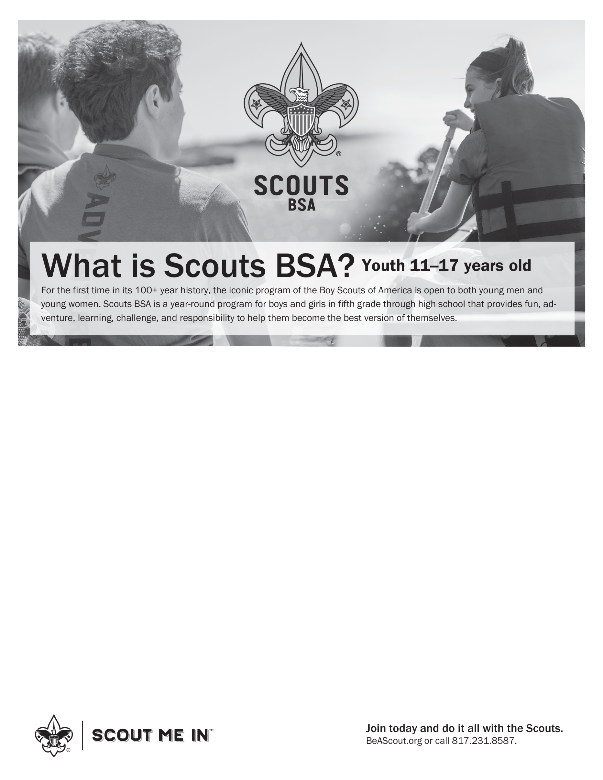


For Boys - Troop ### meets on WHATDAY nights at #:## PM until #:## PM at
NAME OF LOCATION, PLACE OF LOCATION. Please contact LEADER NAME by email (email@email.com) or phone (###-###-####) with any questions.

For Girls - Troop #### meets on WHATDAY nights at #:## PM until #:## PM at
NAME OF LOCATION, PLACE OF LOCATION. Please contact LEADER NAME by email (email@email.com) or phone (###-###-####) with any questions.

Just scan the QR code and click ‘more information’ to get information about upcoming meetings.

We have Troops that meet in different locations, at different times, and on different days of the week.
If you can’t find a convenient location on www.beascout.org, please email helen.kendall@scouting.org

Troop ### – Boys
Troop #### – Girls

